Course Name | ITD 2343 – Object Oriented Programming with C#
Instructor | Mark L. Pranger
Student Name | Lauren Lashley
Due date | February 22, 2026
Grade | <grade earned here>
Grading Comments | <instructor comments here>

Section 2: Week 4 – Week 7 Programming Lab

Show 3 shots of IDE being built: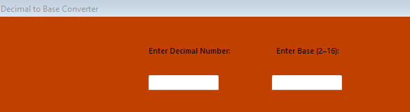

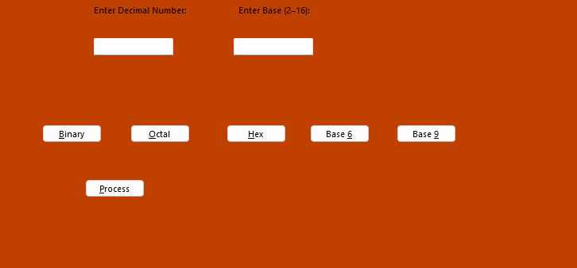
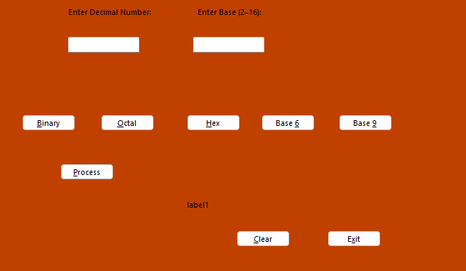

Show program running/ Show program running as it starts (program initiation):

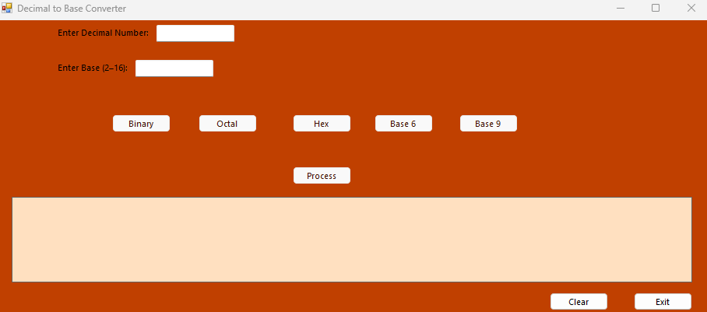

Show the form after the convert to button is selected to covert the current year to base 5 (Functional Operation):
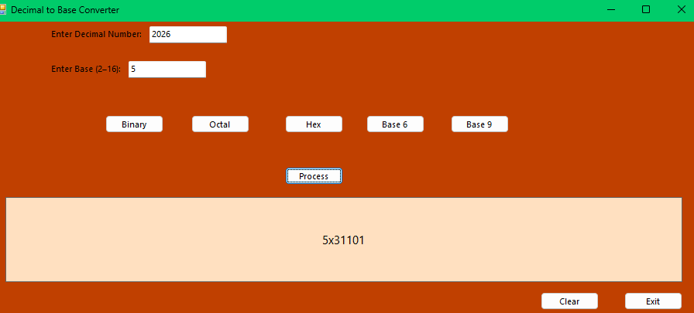

Show the form after the 'base 6' convert button is selected to covert the current year to base 6 (Functional Operation):
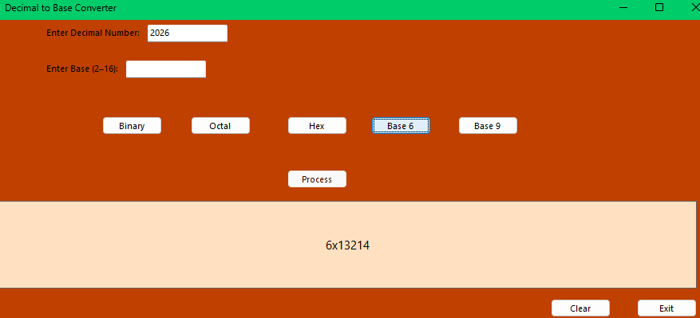

Show the form after the 'base 9' convert button is selected to covert the current year to base 9 (Functional Operation):
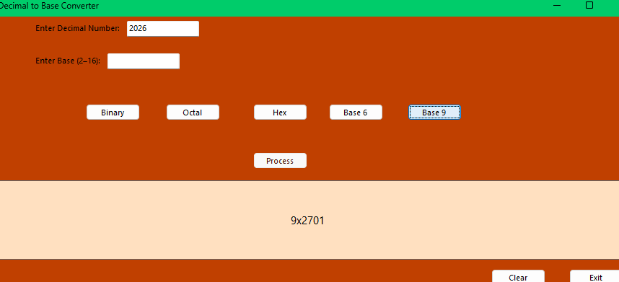

Show the form after the 'hex' convert button is selected to covert the current year to base 16 (Functional Operation):
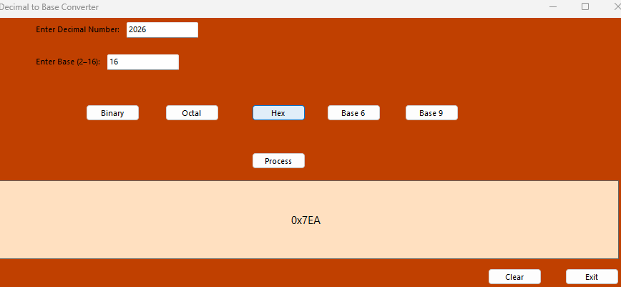

Show the form after the 'binary' convert button is selected to covert the current year to base 2 (Functional Operation):
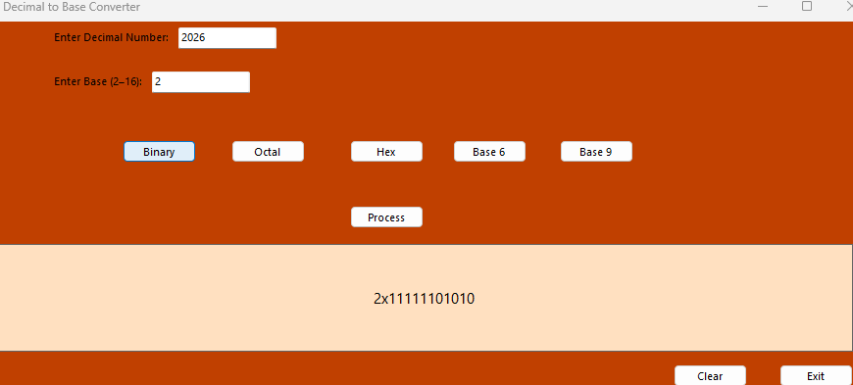

a screen shot showing the error produced when the number 3.141592 is entered for a base (Functional Operation):
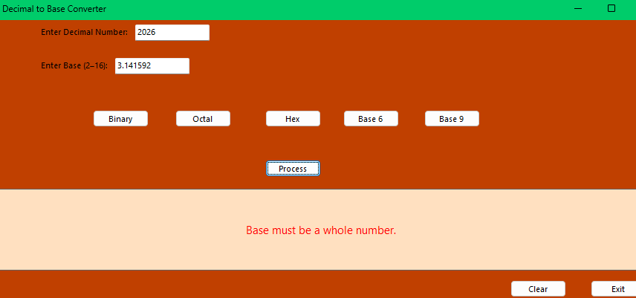

a screen shot showing the error produced when the number 2,016.11 is entered as the 'Convert From' textbox (Functional Operation):
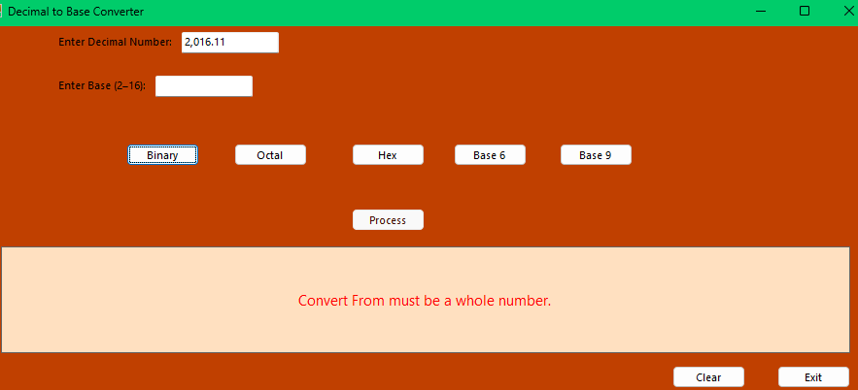

a screen shot showing the error produced when the phrase "What will this do I wonder" is entered into the 'Convert From' textbox (Functional Operation):
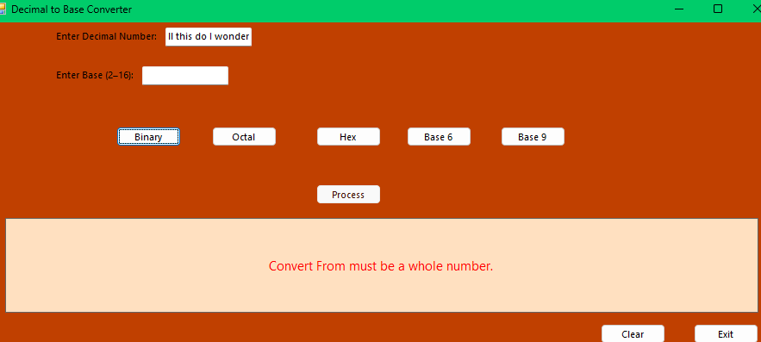

a screen shot showing the error produced when the word "eleven" is entered into the 'Base' textbox (Functional Operation):
